CS 4262 Project Update
Early-Prediction of Harmful Algal Blooms (HABs) with Field Counts and Satellite Features
Trevor Xing-Xie, Nirmay Bhanderi, Connor Brugger
Data Exploration
We downloaded the HABSOS dataset from NCEI, which contains K. brevis cell counts along the Florida Gulf Coast. After filtering for Florida and Karenia brevis and cleaning, we have about 205,000 observations from 1953 to 2024. We binned these into 0.25-degree coastal grid cells and aggregated to weekly time steps, giving us about 54,000 cell-week records across 498 grid cells.
We defined BloomNext as a binary one-step-ahead label where BloomNext = 1 if the max cell count in a grid cell exceeds 100,000 cells/L in the next weekly observation. The positive rate is about 7.3%, so this is a fairly imbalanced problem. We built 10 features from the field data: current and previous week log cell counts and bloom indicators, rolling 4-week statistics, week-over-week change, and field-measured water temperature. The final feature set has about 52,000 samples after requiring 4 weeks of history.
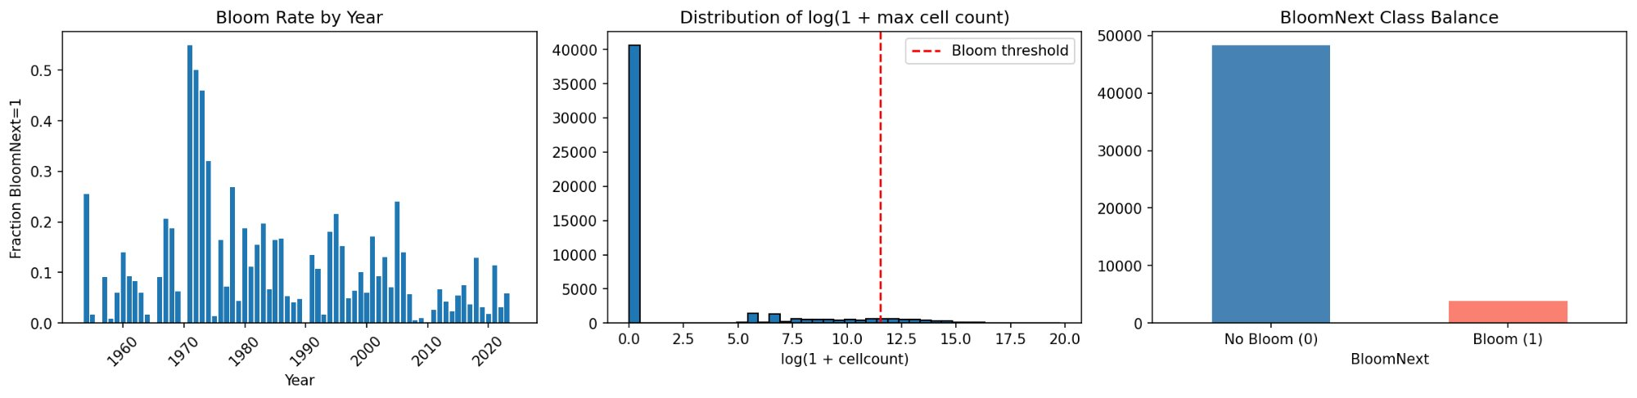
Figure 1: (Left) Annual bloom rate. (Center) Distribution of log cell counts with bloom threshold. (Right) Class balance.
Preliminary Results
We split by time, training on 1954-2022 and testing on 2023-2024. We compared logistic regression, decision trees, SVMs (linear and RBF kernels), and gradient boosting, with class weighting to handle the imbalance.
Model | PR-AUC | F1
SVM (Linear) | 0.493 | 0.354
Gradient Boosting | 0.478 | 0.472
Decision Tree | 0.476 | 0.393
Logistic Regression | 0.473 | 0.401
SVM (RBF) | 0.313 | 0.437

The linear SVM had the best PR-AUC while gradient boosting had the best F1 and highest precision. The RBF kernel SVM did worse than the linear one, which suggests the current engineered feature space may already capture much of the useful signal without requiring a more complex nonlinear boundary.
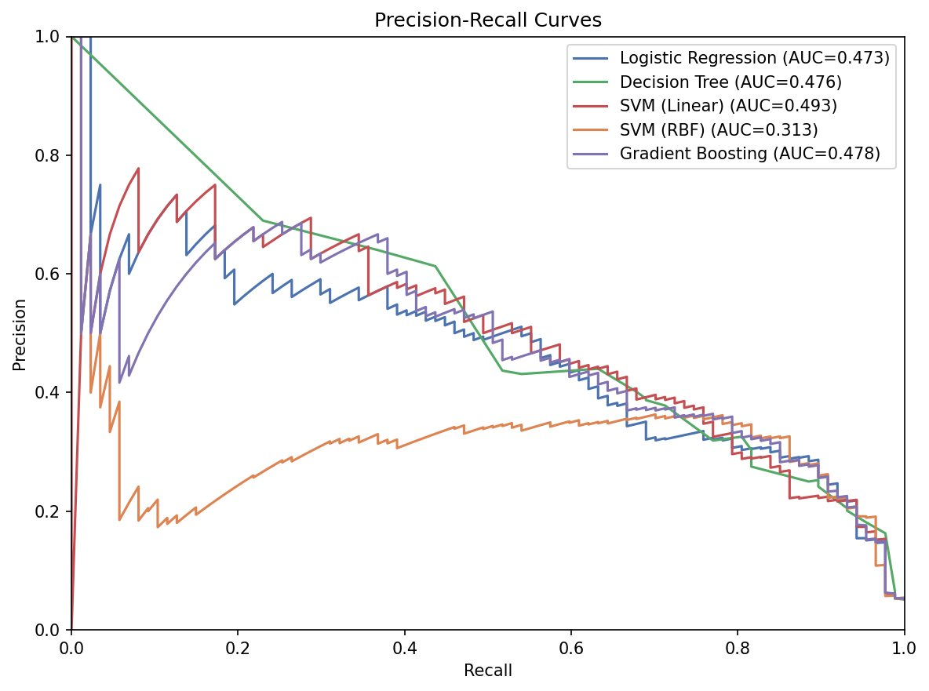
Figure 2: Precision-recall curves for all five models.
Teamwork
Trevor handled data acquisition and initial inspection. Nirmay worked on feature engineering and visualization. Connor built the training pipeline and ran model comparisons. We have been meeting regularly and sharing code.
Next Steps
We plan to add NASA MODIS satellite features (sea surface temperature, chlorophyll-a) and spatial neighborhood features. We also want to tune hyperparameters with cross-validation and explore feature selection. If the feature set gets large we may try PCA for dimensionality reduction. We might also try a regression target (predicting log cell count) instead of just binary classification. So far, this update reflects a baseline model built primarily from HABSOS field observations, with satellite-derived features planned for the next phase.
References
Blumenfeld, Josh. “Applying Machine Learning to Harmful Algal Blooms | NASA Earthdata.” NASA Earthdata, 13 Feb. 2024, www.earthdata.nasa.gov/news/blog/applying-machine-learning-harmful-algal-blooms.
“Harmful Algal BloomS Observing System (HABSOS).” National Centers for Environmental Information (NCEI), 15 Oct. 2020, www.ncei.noaa.gov/products/harmful-algal-blooms-observing-system.

